Software Requirements Specification for   
Online movie Streaming

Document ID: ASP-CMS-SRS-02.doc

Author: Dineshkumar M

Version: 0.2

Date: April 17, 2024

1. Objective and Scope 3

2. Project End Users 3

3. Features 4

3.1 Login validation 4

3.2 View movies with genre classification 4

3.3 Search Movies... 4

3.4 View each movie details…. 4

3.5 Watch movies **…………….…………………………………………………………………….………..4**

3.6 Logout…………..**…………….…………………………………………………………………….………..4**

4.Specific Requirements ……………………………………………….………………………………………..5

**5. Use Case diagram ………………………………………………….…………………………………………..5**

**6.Architecture diagram.....................................................................................................6**

**7.Class diagram…………………………………………………………………………………………………….7**

**8.Sequence diagram………………………………………………………………………………………………8**

# Objective and Scope

The objective of the online movie streaming site is to provide users with a platform to easily discover, browse, and watch a wide range of movies conveniently from any internet-connected device. The system aims to offer a seamless and enjoyable movie viewing experience while allowing users to access a diverse catalog of films. The scope of the product includes the following basic features:

User Profile and Personalization: User profiles with customizable preferences and settings. Ability to create watchlists, mark favorites, and receive personalized recommendations based on viewing history.

Accessibility and Compatibility: Cross-platform compatibility (web browsers, mobile apps, smart TVs).Responsive design for seamless viewing on different devices.

# Project End Users

Those who use web applications to watch movie online.

# Features

## Login validation

**Login**

Provide a login form on the website where users can input their User Name and Password.

**Create Account**

Create your account to view and watch movie and personalized recommendations. Fill in the details to set up your account. Provide email, username and create password and sign up.

Each user should be authenticated with a User Name and Password to login into the system.

## View movies with genre classification

Each authenticated user can view home page with top movies and movies classified with genre

## Search movies

User can search movies/series with names or genre and can help direct them into the searched movie.

## View each movie details

User can view movie details like name, cast, year , ratings and also add them to favorites.

## 3.5 Watch movies

User can watch or series on the website online and it’s require mobile data or wi-fi with good speed.

## Logout

User can logout of their account once their complete watching the movie/series.

# Specific Requirements

## Functional Requirements:

1. **User Authentication and Authorization**:
   * Users should be able to register, log in, and log out securely.
   * Admins should have specific privileges to manage content and user accounts.
2. **Browse and Search Functionality**:
   * Users can browse movies by genre, release year, popularity, etc.
   * Search functionality to find specific movies or TV shows by title, actor, director, etc.
3. **User Profile and Preferences:**

* Users can create and manage their profiles.
* Ability to create watchlists, mark favorite movies, and receive personalized recommendations.

## Non-Functional Requirements:

1. **Performance**:
   * Scalability to handle increasing numbers of concurrent users.
2. **Security**:
   * Secure authentication and data encryption to protect user information.
   * Measures to prevent unauthorized access to content.
3. **Compatibility**:
   * Support for various devices and platforms (web browsers, mobile apps, smart TVs).
   * Cross-browser and cross-device compatibility for a consistent user experience

# Use case diagram

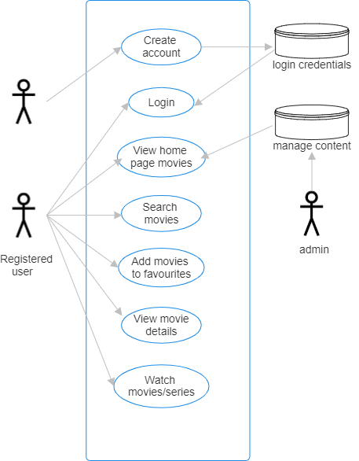

# Architecture Diagram

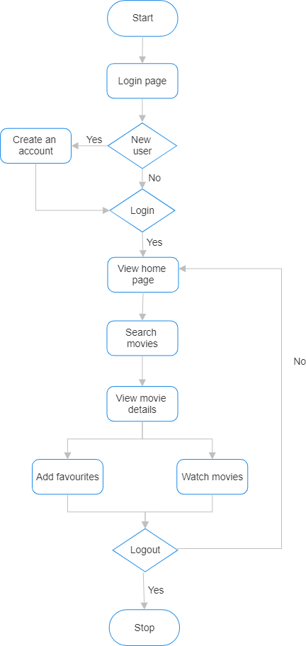

# Class Diagram

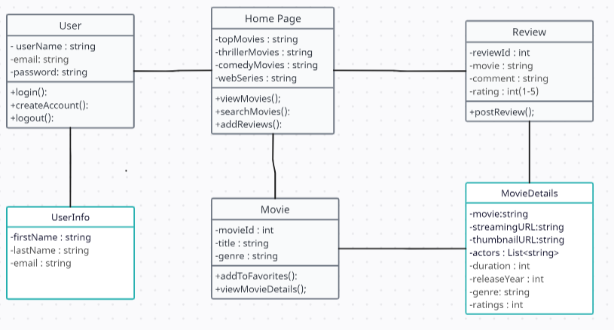

# Sequence diagram

